

**Abstract:**

You hopefully have heard about the z/OS Installation Strategy? This is an undertaking that is across the entire z/OS industry (with strong participation from both IBM and ISVs) to provide a common installation and packaging method that you use from z/OSMF.

This self-directed lab will take you through each step needed to create a portable software nstance (PSI).

So, your company Hooli has developed a great new product called “The Box IIII”! You now would like to package this product up as a Portable Software Instance so you can distribute it to you customers. What’s next? A very simple creation of a PSI using z/OSMF Software Management.

*What level of z/OSMF do you need to package a PSI? Ensure you have the appropriate z/OSMF Software Management support installed:*

* *z/OSMF V2.2 with PTF UI44516 , or*
* *z/OSMF V2.1 with PTF UI42018*

Note: Subsequent enhancements are being made to z/OSMF Software Management all the time. To find them, just use the SMP/E FIXCAT IBM.DrivingSystem-RequiredService.IBM.DrivingSystem-RequiredServiceIBM.DrivingSystem-RequiredServiceIBM.DrivingSystem-RequiredServiceThe Exercise instructions heading should use paragraph style ***Heading 2 (new page)***.

You can start a new part of the exercise with an introductory paragraph, or jump directly to the steps required to complete the part.

When composing exercise steps make sure you start with a major numbered step using style ***Steps***. This numbered step describes what will be done. Experienced students can attempt to complete this step just by reading and doing what’s in the numbered step. Follow with lettered steps which describe in detail how to accomplish the major step. These minor steps are also of style ***Steps***, but are indented using the tab key, or the indent buttons on the toolbar.

See the example below:

When you follow this self-directed lab, here is a high-level overview of what you will learn:

1. Logon to z/OSMF with your supplied lab id and password.
2. Create a PSI of a software product using z/OSMF Software Management’s Software Instances and Portable Software Instances tasks.

Logon to z/OSMF.

#1a

In this step, we will now go into z/OSMF to use the Workflow Editor function. For this lab, we are using a z/OSMF 3.1 system.

* Go to <https://share.centers.ihost.com/zosmf/> on the Firefox or IE web browser. (If you want to follow this lab on your own system, that is fine. Just note some of the samples we use you will need to supply yourself, using the Appendix to find those samples.).
* Using the userid you were given (SHARAnn, SHARBnn, or SHARCnn) and the password, logon to z/OSMF. The userid you were given is a regular z/OS userid on this system and has been given access to z/OSMF. There is *no* z/OSMF code on this workstation, all executables (except the web browser) are on the z/OS system.
* Click on “LOG IN”.

#1a

**https://share.centers.ihost.com/zosmf/**

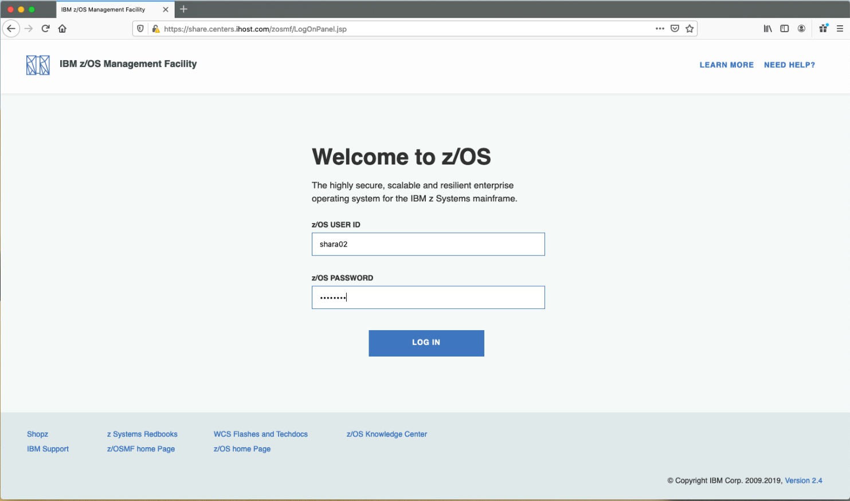

#1b

#1c

Click on “**Software Management**”.

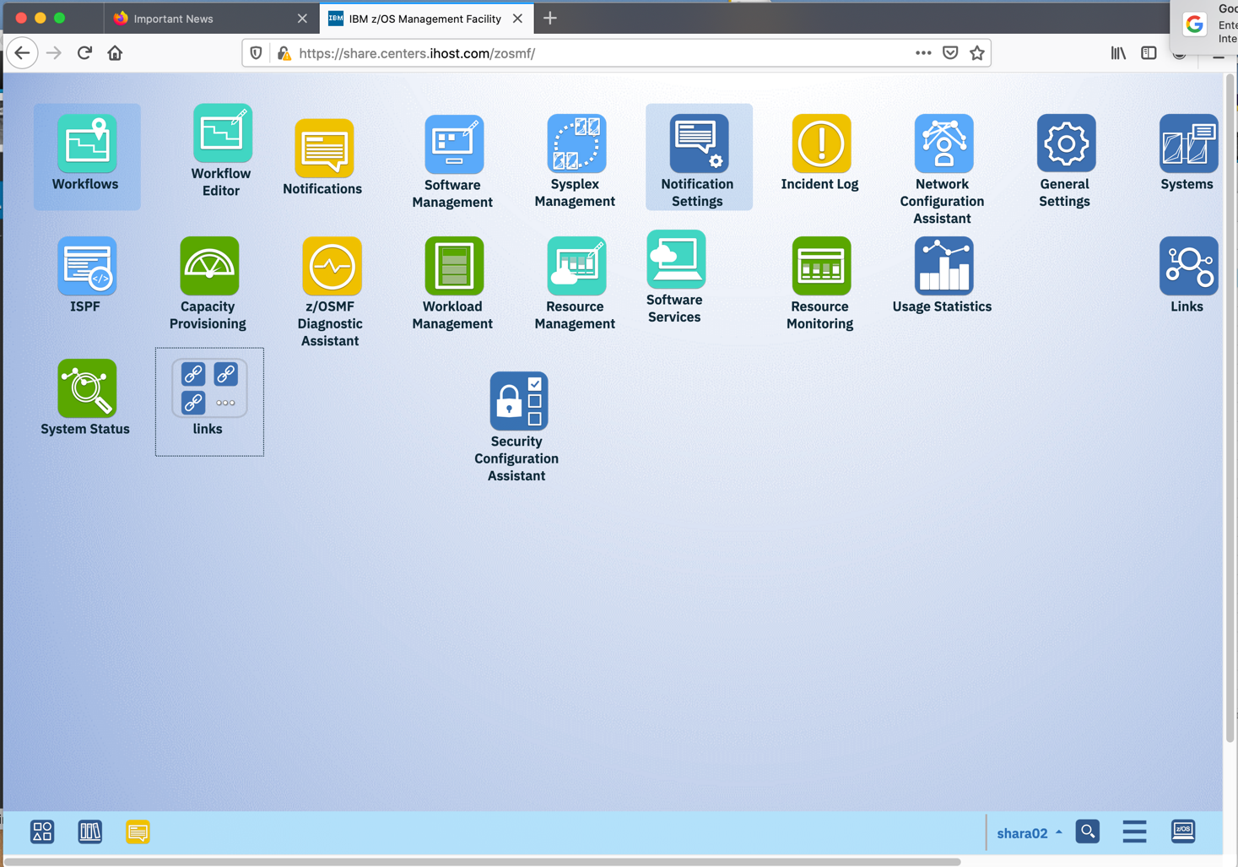

Role of the Software Vendor: define a Portable Software Instance

First, let’s see how anyone, including z/OS software vendor, could provide the product we described before. There are two portions of defining a Portable Software instance:

1. Creating a Software Instance, and
2. Taking that Software Instance and making it (“exporting”) a Portable Software Instance.

**We will now go through the creation of a Software Instance**

Click on “**Software Instances**”.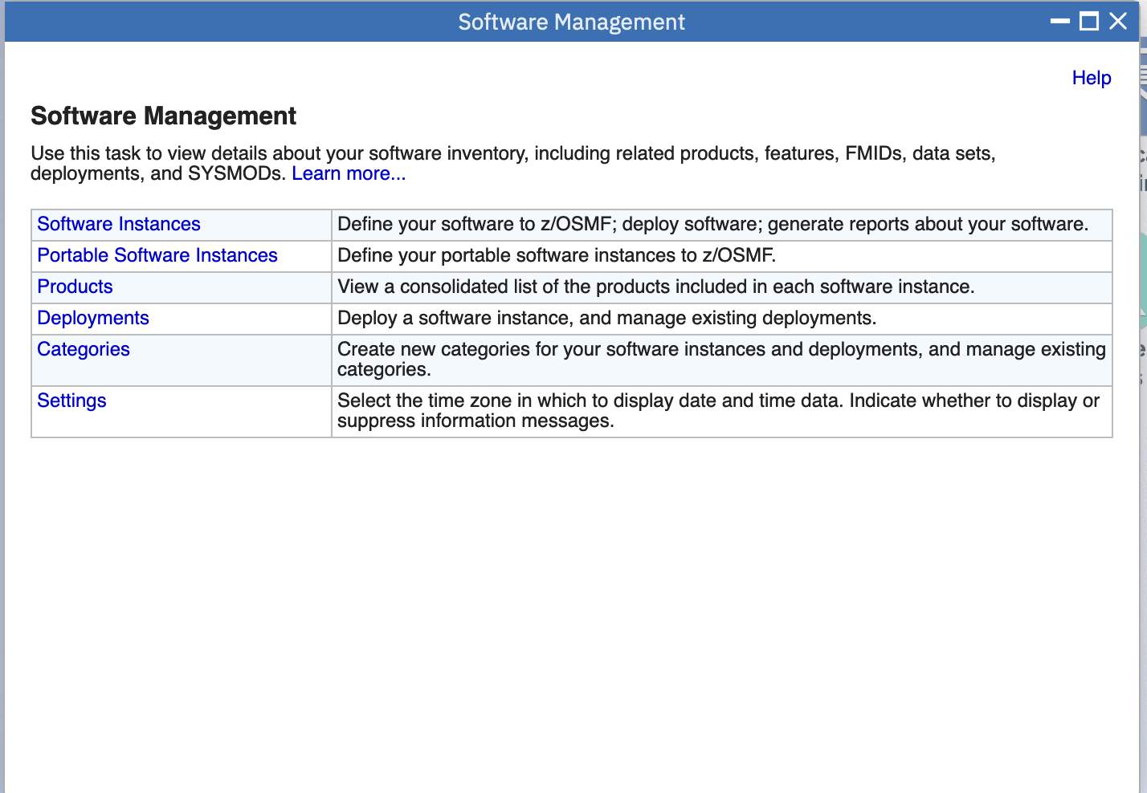

You will probably see many Software Instance already on the system. You want to create a new one. Click on **Actions-> Add**.

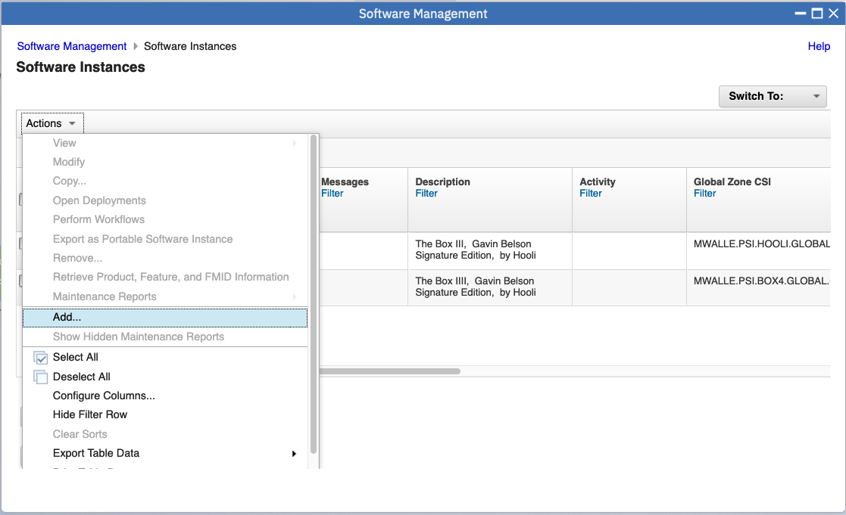

Now, we have to provide some details for our Software Instance. You can see the mini-wizard on the left; the steps we need to go through. Provide the following information:

* **Name**: use the userid you are logged onto z/OSMF with, and **-PSI-V1R1.** For instance, if you were logged on with SHARA02, your **Name** would be **SHARA02-PSI-V1R1.** We are putting the V1R1 to indicate the release level of this product.
* **Description:**  give whatever description you like, to describe this product (Software Instance).
* Click **Next>** to continue.

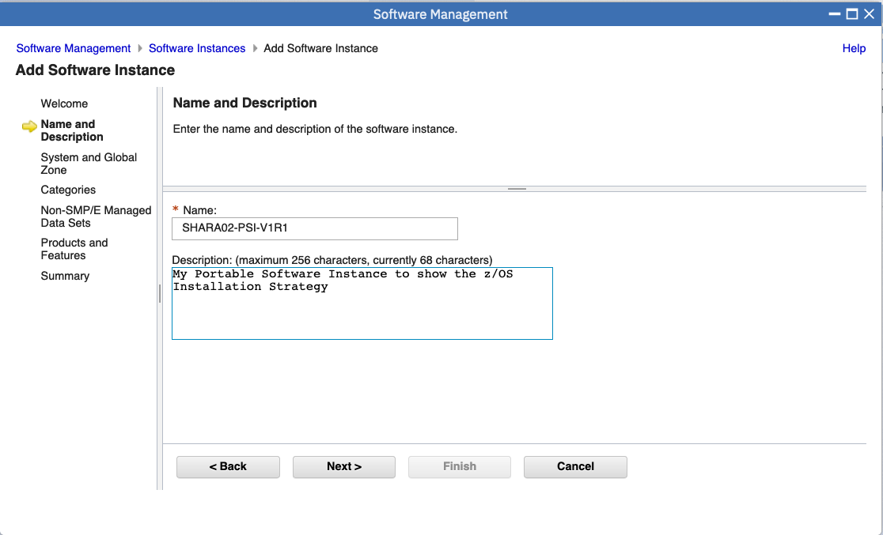

* This is where you say what system contains the contents of your Software Instance. We are using the same system we are logged onto for this lab, so select **S2** from the System pull-down.
* We need to add the name of the SMP/E CSI we have installed into. Everyone has to enter **MWALLE.PSI.HOOLI.GLOBAL.CSI** here, because that is where the SMP/E-installed portion of our product has been installed for this lab. All lab user IDs have read access to this data set.
* Continue on with **Next>**

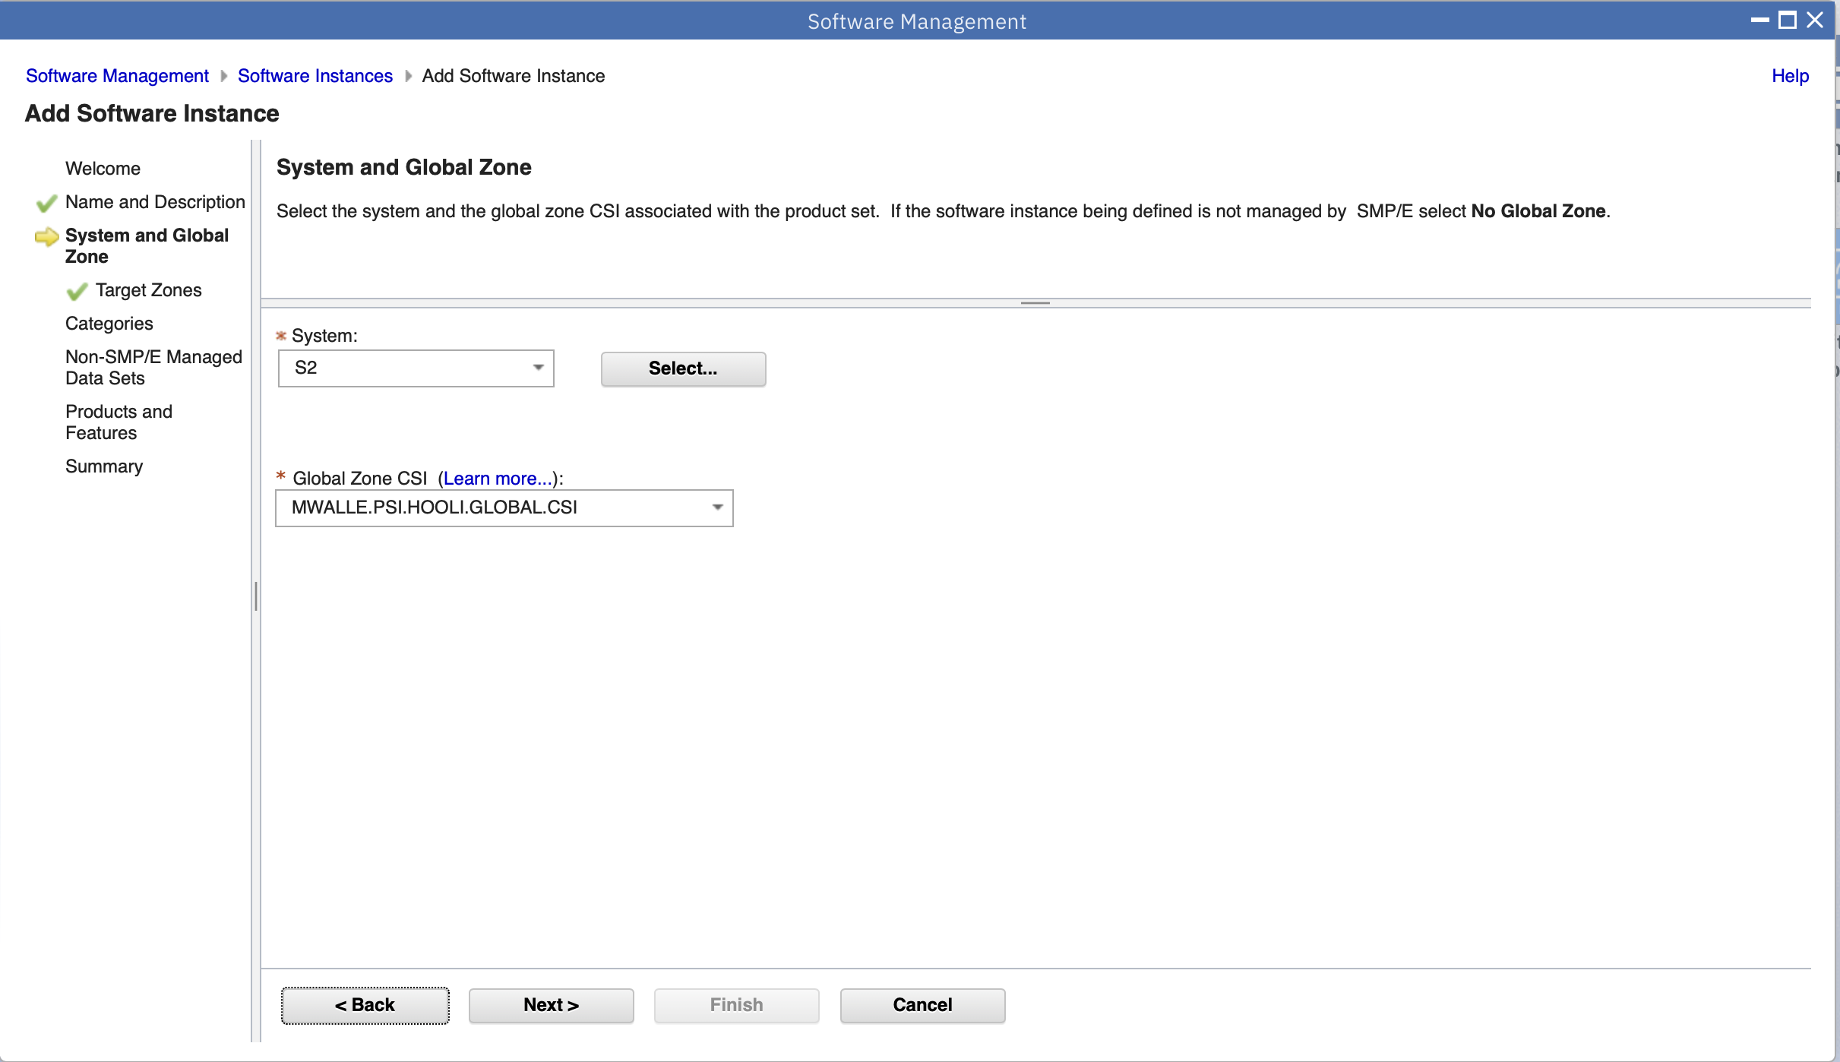

* This is where you can say which zones you what of the CSI. We want to include all the zones, so select the box next to Target.
* Then click **Next>**

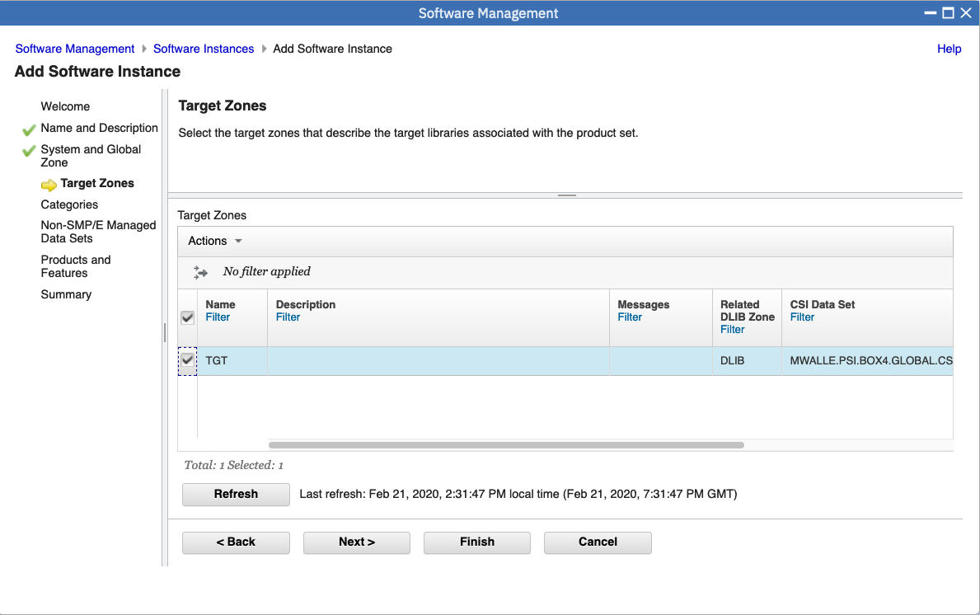

* The next screen is for a Category, if we wanted to specify one. We aren’t going to use a Category for this lab, just click on **Next>.**

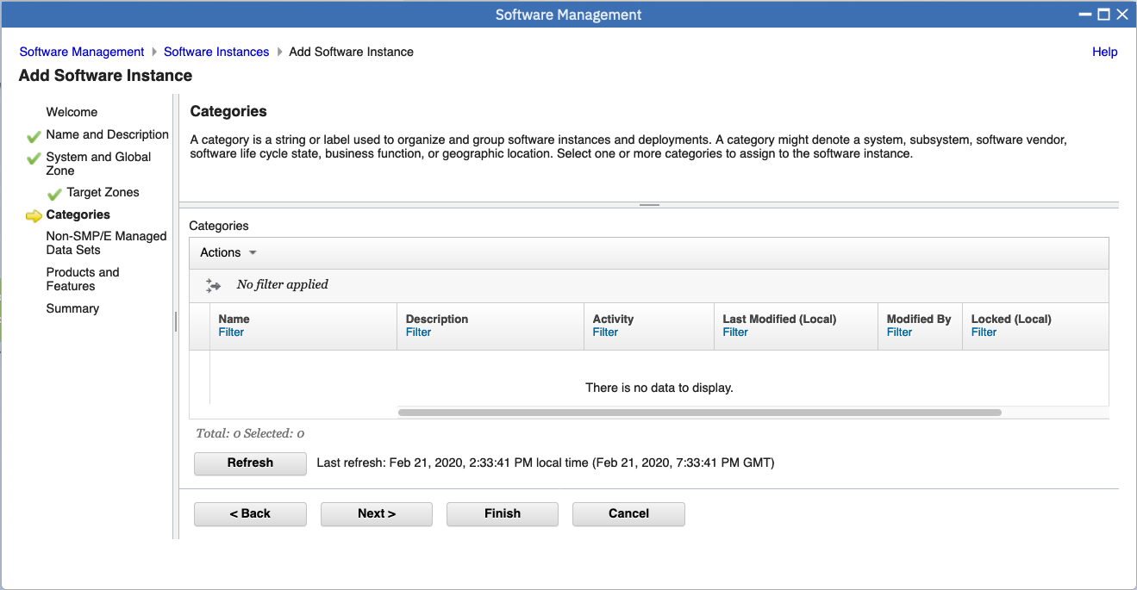

* Now, we get to the part we have to add the non-SMP/E product to our Software Instance if we had one. Let’s assume that our product deliverable has no non-SMP/E data sets. For this lab we Click on **Next>.**

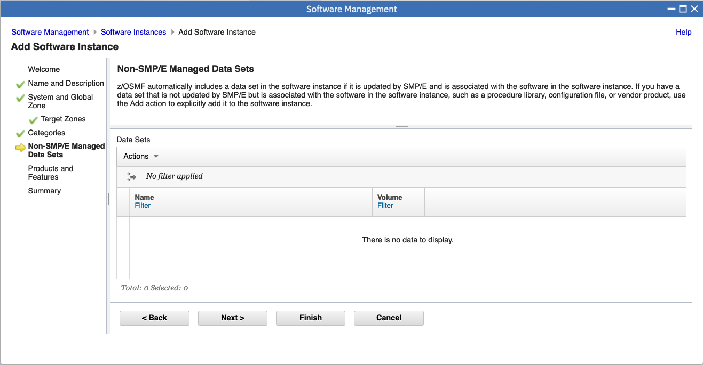

* The next section is to identify and products and features associated product. You could add information here if you like, for customers to know about this product. Let’s put some information there.
* Click on **Actions -> Add.** Add any information you’d like, including Features (with an **Actions -> Add) – remembering to select them.**
* Click on **OK.**

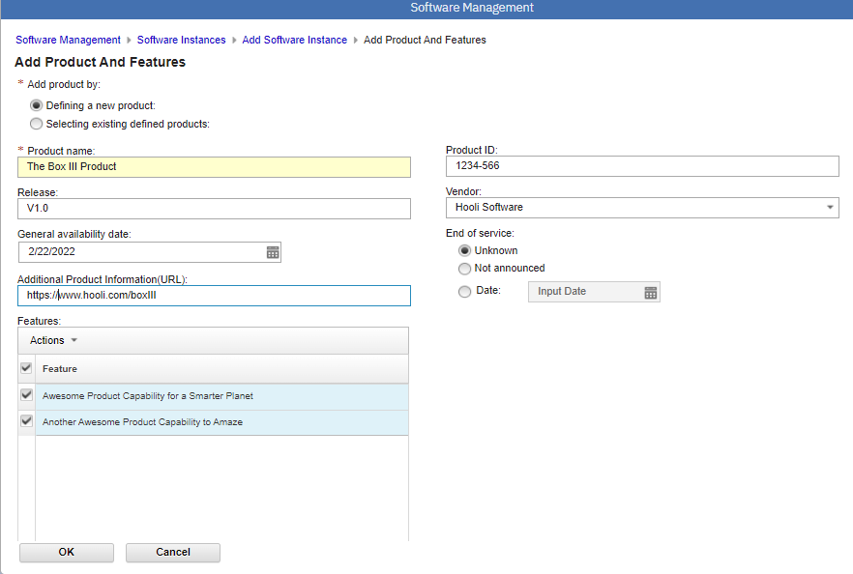

* Select the Product, and click on **Next>**

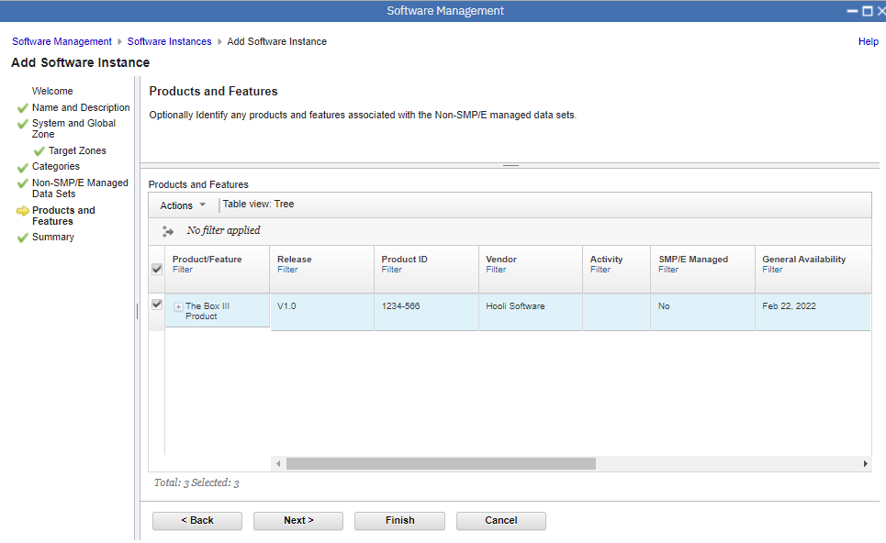

Does everything look good on your Summary page?

We are almost done packaging up our Software Instance, with the exeption of our Workflows… This screen summarizes the contents of our package. You can browse through it. You’ll see the SMP/E portion of our product (only the Global CSI), and the non-SMP/E portion of our product (the six data sets we added). Click **Finish** and we are done!

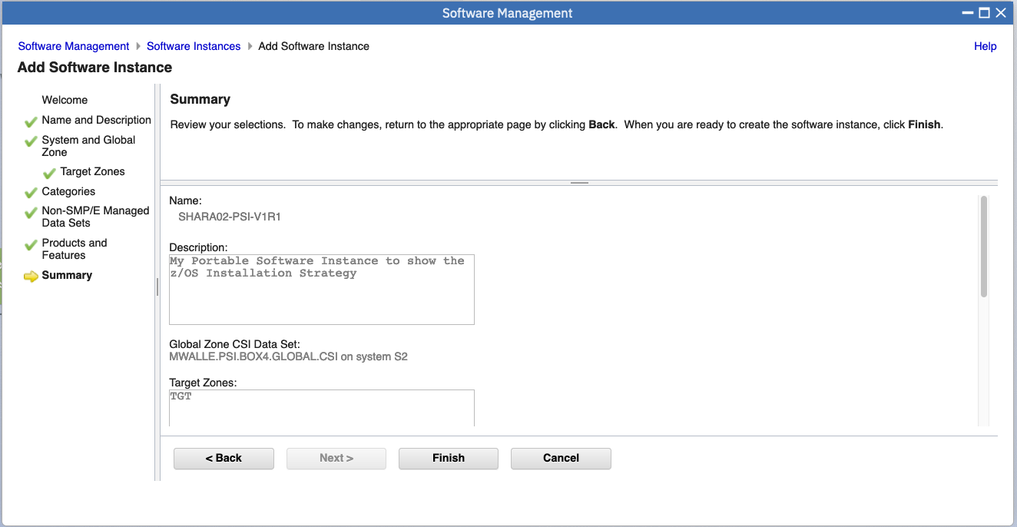

You will now see your Software Instance. We still need to add our Workflows that we are shipping to aid in the setting up of our product. Select your Software Instance and click **Actions->Modify**.

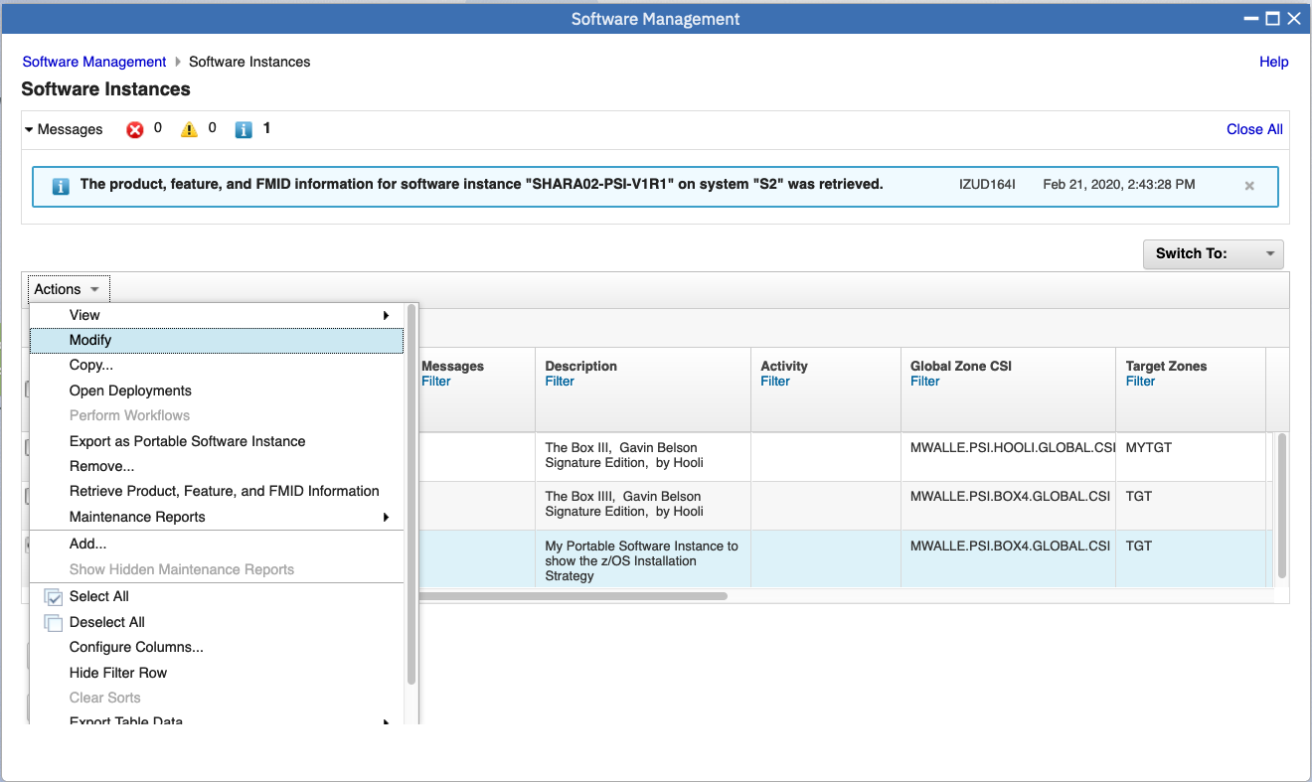

Click on the **Workflows** tab.

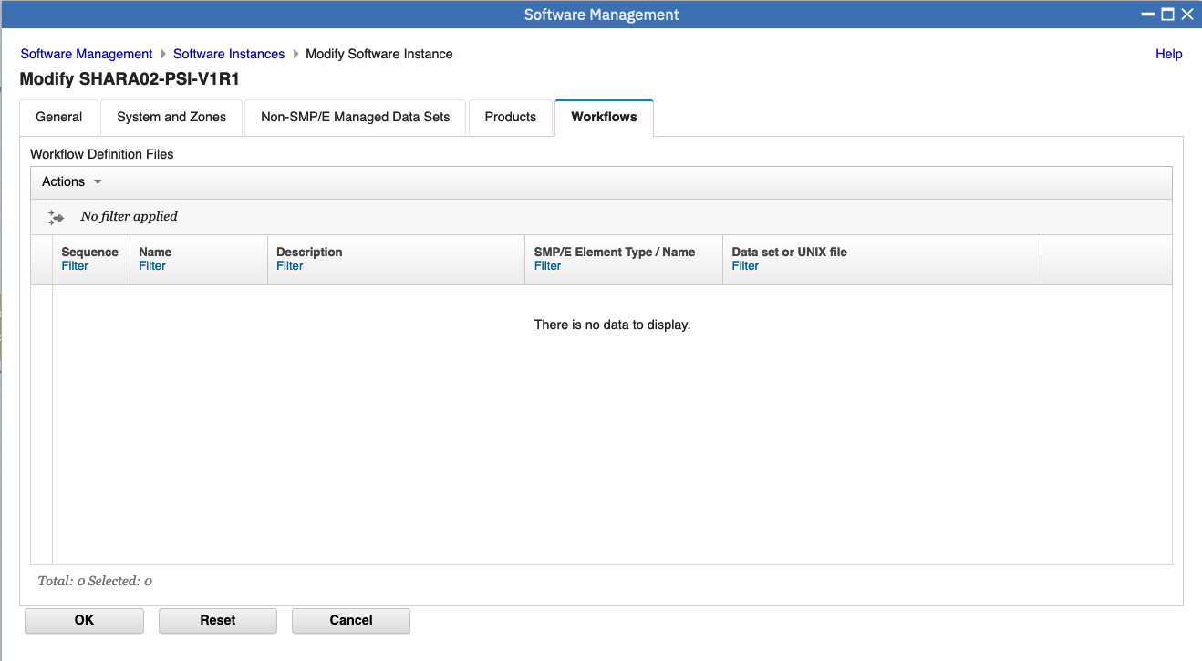

Now we want to add our Workflow dataset to the Software Instance. Click on **Actions->Add**.

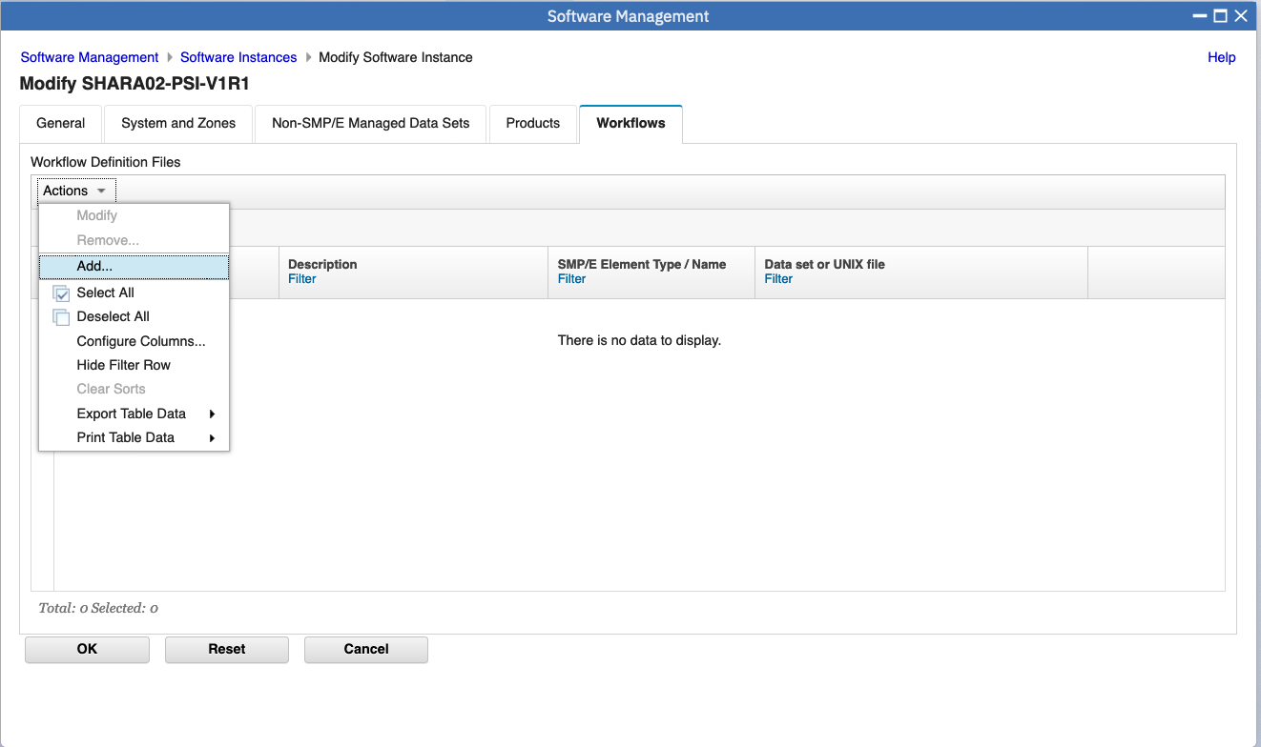

Here we will give a Name, Description, and location of our workflows. You can give any Name and Description for your workflows. Select Must Perform on z/OSMF Host System **Yes.**

For the location of the workflow definition file, select **No** for Is defined file SMP/E managed.

For the data set name use: **MWALLE.PSI.HOOLI.WORKFLOW(HOOLWELC)** for the **1** Sequence.

Click on **OK**. Then continue to add more workflows.

Add **MWALLE.PSI.HOOLI.WORKFLOW(HOOLSETU)** for **2** Sequence.

Then add **MWALLE.PSI.HOOLI.WORKFLOW (HOOLIVP)** for **3** Sequence

These three workflows represent a Welcome workflow, a configuration workflow for setting up the product, and a verification program after the product has been activated.

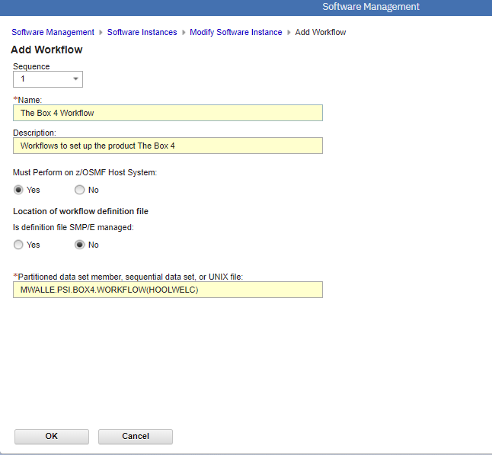

Make sure you have selected all the workflows you want to include (3 of them) to our Software Instance. Click on **OK**.

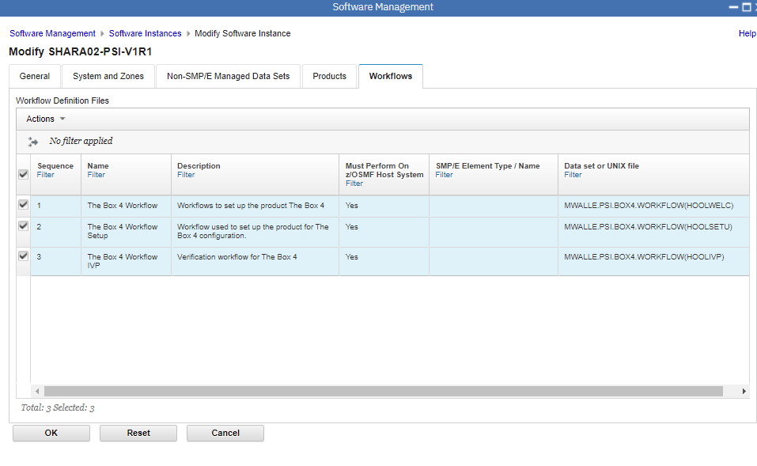

*Let’s recap:* we packaged a product into a Software Instance that contained the contents we desired. This isn’t new and creating Software Instances is a very old function in z/OSMF Software Management. Now, let’s get to the newer part specifically…taking that Software Instance and making it a Portable Software Instance (PSI).

We need to make the PSI so that we can distribute it to our paying customers, and they can use this great new product our company (Hooli) has produced.

The PSI is a package that can be acquired by our paying customers and stored into z/OSMF for installation. Creating a PSI is very easy, once you’ve got your Software Instance defined!

On the Software Instances main screen (where all the system’s Software Instances have been defined), select your Software Instance (called something like **SHARA02-PSI-V1R1),** and then **Actions -> Export as Portable Software Instance.**

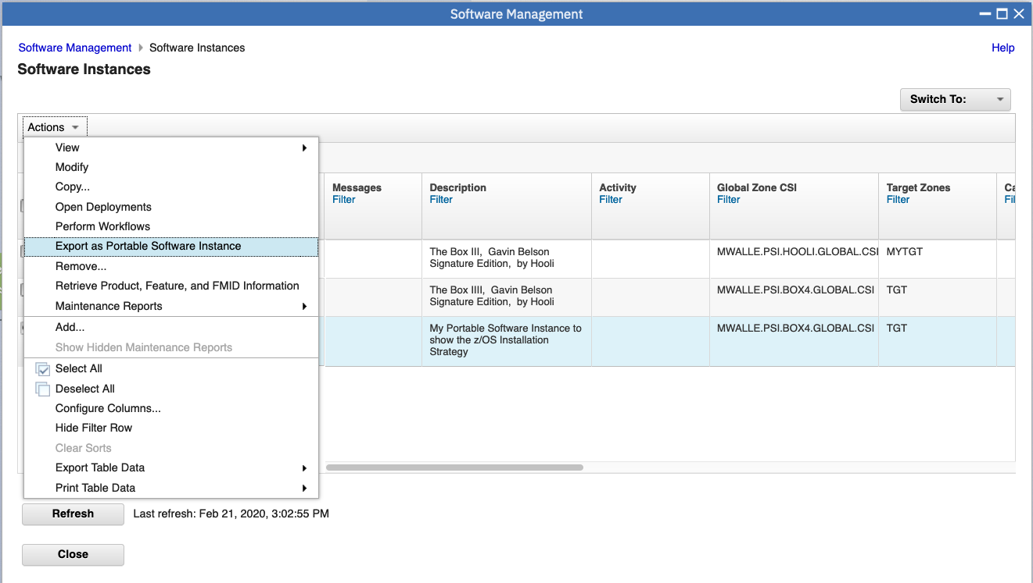

You need to provide some information. Say:

* Add a check for exporting the distribution zones and libraries. We definitely want our customers to have all the complete SMP/E installation information.
* You can ignore “Enable merging of target data sets when deploying the portable software instance.” and “Sign the portable software instance.” for this lab.
* a location where the PSI will be stored. This location will be filled in by default, however that default will not work on our lab system. Change the UNIX directory to be **/u/<your user id>/SHARA02-PSI-V1R1 ,** updating the purple part with the lower case of your assigned userid. This is case sensitive.
* The JCL data set name default should be fine. This is the location where the export JCL will be saved, in case you want to see it later.
* If not already there, add, REGION**=0M** to the end of the JOB statement.
* Click **Next>.**

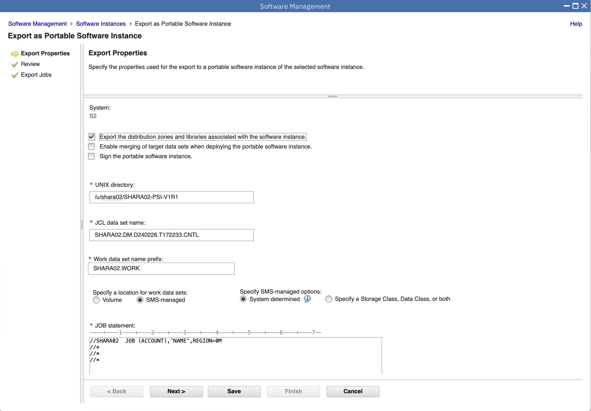

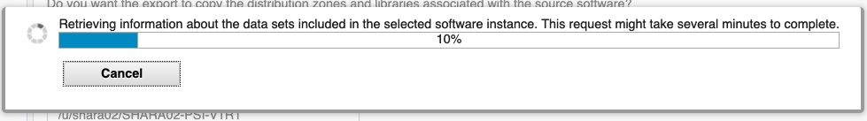

You should then see several review tabs. Click through each one…this is what will be put into your PSI. You can see that there is both SMP/E Zones, Data Sets (including the workflow), and since we do not have a z/OS UNIX file system that section will be blank. Just what we wanted! Notice, PSIs can include any type of data set: file system, VSAM, PDS, PDSE, sequential …

Click **Next>.**

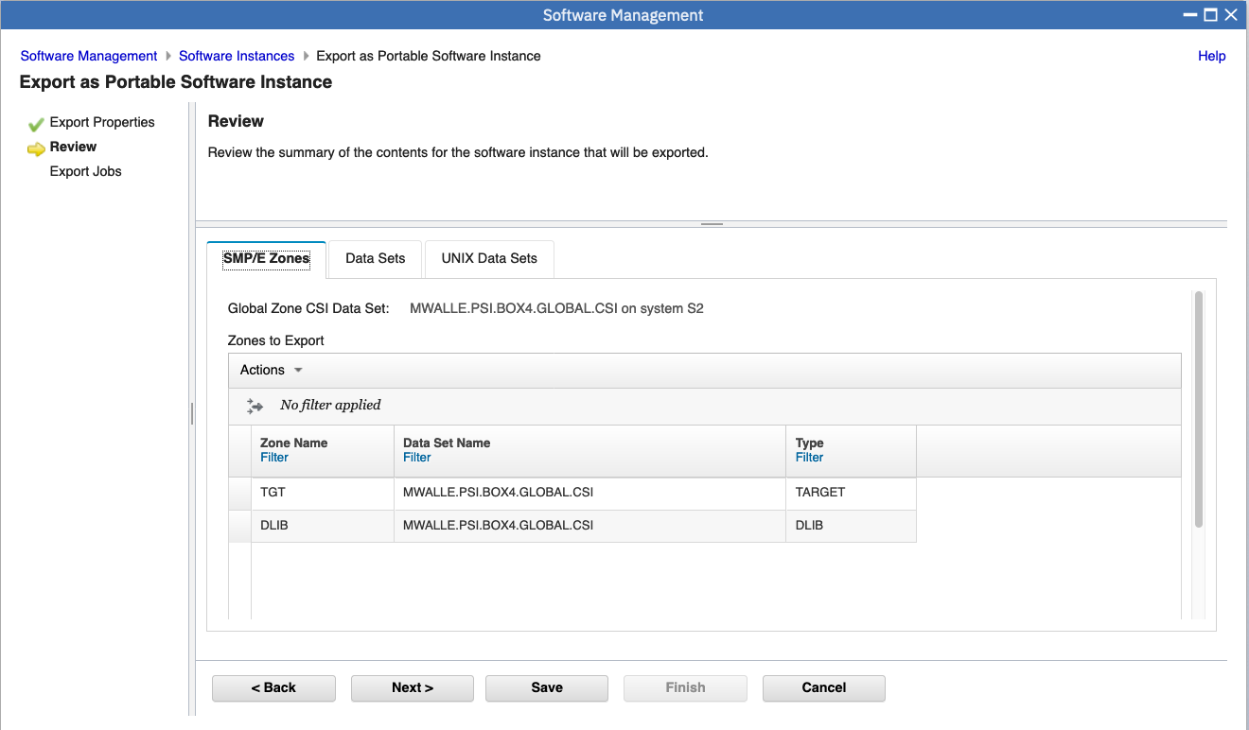

You can now see the JCL that will do the export to the PSI. You can browse it if you like, by clicking on the blue job name:

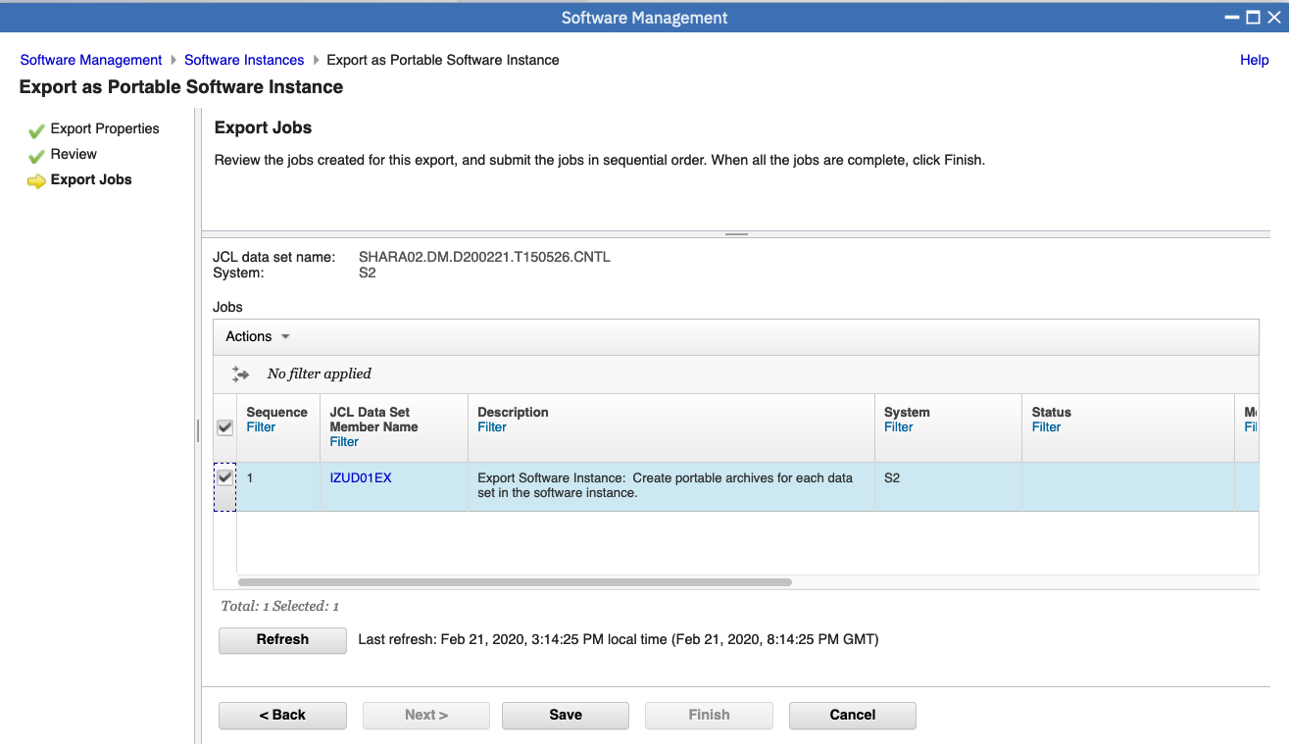

With the job selected do **Actions -> Submit job.** Once submitted you will get a message that the job has been submitted.   


Give the job about a minute to run, then Click on **Refresh**. When completed successfully, you can look at the output by using **Actions -> View -> Job output**. You should have all rc=0’s.

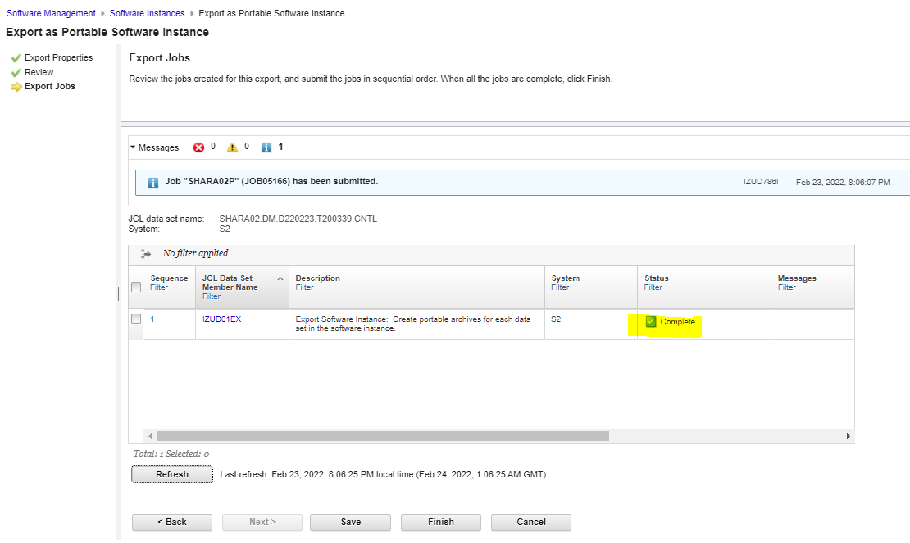

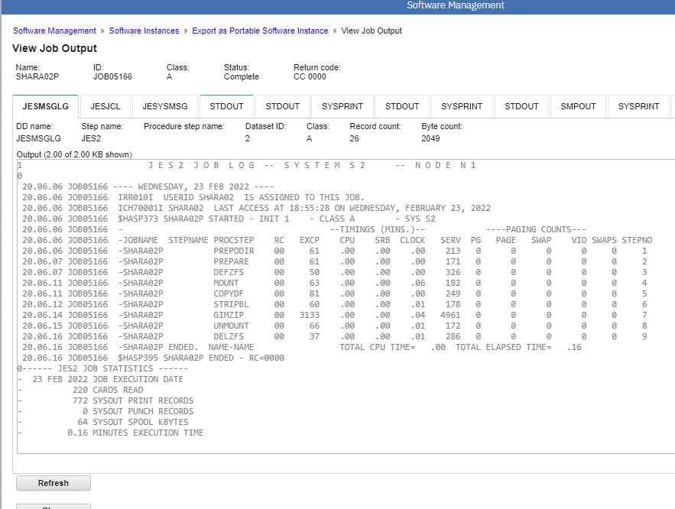

**Finish** would be available to click. If your job completed successfully, you would find your PSI located in **/u/*userid/USERID-*PSI-V1R1.**

If you click on the little magnifying glass in the very low right hand corner, and fill in your path name, you can see the package:

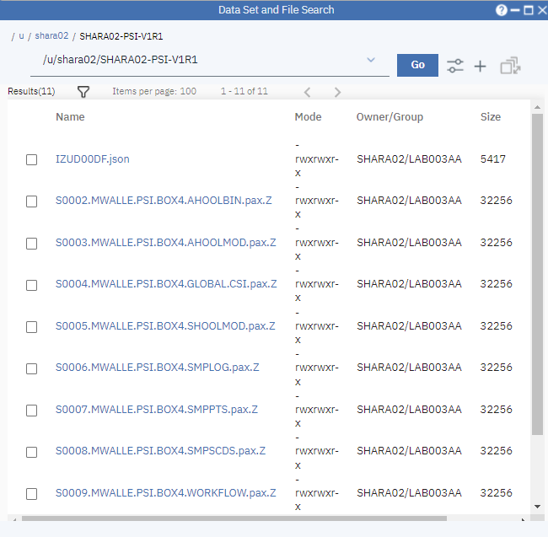

We are now ready to send our product to paying customers and have them install it with z/OSMF.

**Clean up**

After you’ve done all the poking around that you like, it would be nice of you to delete your Software Instance and your Portable Software Instance to keep unnecessary SI’s and PSI’s cleaned off the system.

From the Software Management window, go back to Software Instances and click on your own SI, then click **Actions -> Remove**.

From the Software Management window, go back to the Portable Software Instances, select your PSI and click **Actions -> Remove**. (Note: If your job failed *expected* you will not see your PSI)

Thank you for being a good user on our system!